Charles Kelly Home & School Association

WELCOME BACK

2021-2022

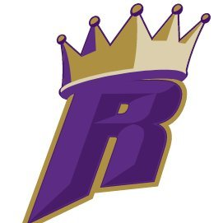

Welcome back Charles Kelly ROYALS

I’m super excited to kick off my 10th year here at Kelly. I have been Home & School President and I’m looking forward to a fun and safe year. Last year due to Covid we did not have any events or fundraisers, so we really need to get things rolling again.

***Please join us on 9/23 for our 1st meeting of the year 630-730***

***Box Tops are BACK and we NEED them!***

PUMPKIN NIGHT will be back this year…………more info to come

Charles Kelly Sprit Wear is now on sale…please visit <https://brothersscreen.tuosystems.com/stores/charles-kelly-elementary-21>

Gina 484-469-1411 or [daemonmark4life@yhaoo.com](mailto:daemonmark4life@yhaoo.com)